LEAKS AND ALLOWANCES

There is a leak on the pipe supplying water to my home or business; who is responsible for fixing it?
It depends where the leak occurs. The simple diagram below illustrates which part of the pipe is the responsibility of NI Water and which is yours as the customer.

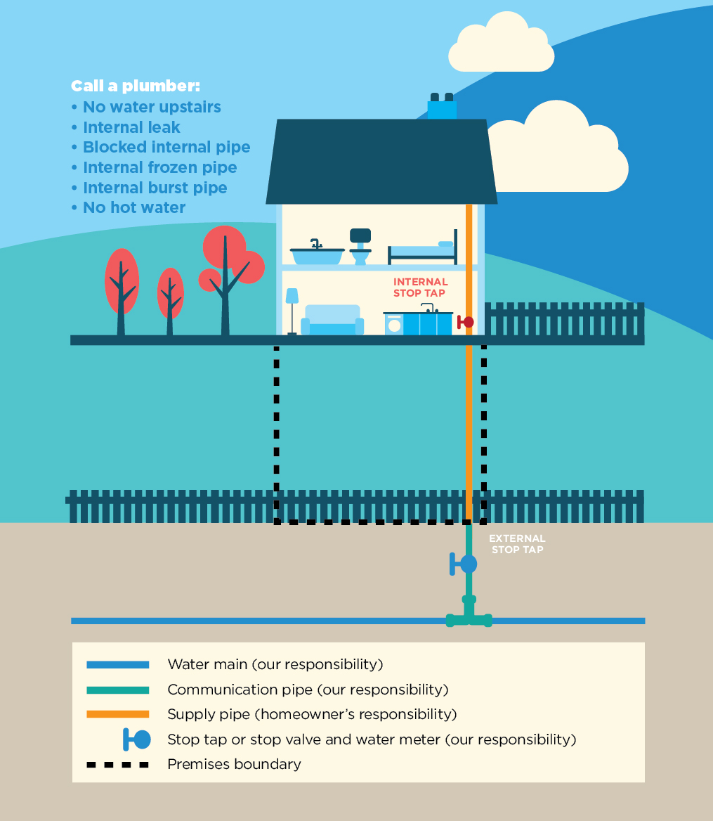

Regardless of where the stopcock is installed once the pipe enters your property you are responsible for maintaining it. This means you are also responsible for any leakage on your section of pipe.

Anything on the public side of the property boundary is up to NI Water to look after.

Once you become aware that you have a leak, you must take steps to repair it. A cracked or damaged pipe can lose thousands of litres of water per day and NI Water can serve a legal notice on you requiring you to make the repair.
If you do not own your property, your landlord may be responsible for fixing the leak, but the bill payer will still be liable, even if the leak is on a shared supply pipe within the property. If necessary you should ask your landlord, or the property owner to carry out the repair.

What will I have to pay for?
If the leak is on a section of pipe that is your responsibility then you will have to pay for the repair.
If the leak occurred on a section of pipe that is NI Water’s responsibility to look after, or it is as a result of damage caused by NI Water or their contractors, they will repair it and you will not have to pay any additional costs because of water that leaked.
If you are a metered non-domestic customer you will also have to pay for all water supplied through the meter. If you do not tell NI Water that the water leaked, they will also charge you for sewerage based on all the water measured by the meter.

Can I get my bill reduced? (measured customers only)
All water supplied through a meter for non-domestic purposes and the resulting wastewater returned to the sewer will be billed.
If a leak has occurred, you can apply to have the sewerage charges on your bill adjusted to take account of the water which leaked and did not reach the sewer.
Under some circumstances NI Water can reduce the amount on your bill. However this depends on where the leak occurred and how quickly it was dealt with.
In order for NI Water to review your account following a leak on your supply, you must apply for a Leakage Allowance.
Depending on the location of the leak within your property and what your supply serves, you may be entitled to a reduction on your bill.
In order to review your account, you must complete a Leakage Questionnaire. This is available by calling Waterline 03457 440088, or Billing Line 03458 770030. Alternatively you can download a copy of the form at www.niwater.com/leakage-responsibilities-allowances-and-costs/ and return it by post or by email.
Post: email:
Northern Ireland Water customer.billing@niwater.com
PO Box 1026
Belfast
BT1 9DJ
What can I do to prevent leaks?
Depending where a leak occurs on the water pipe it can affect one or many customers through reduced water pressure, property damage, repair costs, and potentially increased bills.
There are some steps we can all take to prevent leakage. Prevention is better than cure so please take precautions against leakage, especially in cold weather. The following steps can help:
- Insulate all exposed pipework. This will help slow down any freezing in prolonged cold weather.
- Fit stopcocks on supplies that you know you won’t be using for long periods so you can drain the pipes when they are not in use. Place these on your section of the supply pipe as close as possible to the boundary.
- Fix any drips or slow leaks you know about. A slow run of water freezes faster than still water in a pipe because of the way the ice builds up. Keeping a tap running slowly will show if you still have a water supply, but it is wasting water, and it can just make things worse.
- Make sure new supply pipes are deep enough in the ground. A water supply pipe should be at a depth of 750mm (2½ feet) from the surface. This can protect it from freezing in cold weather and from accidental damage from digging or ploughing the ground.

