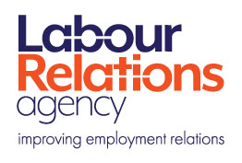


Seasonal Staff Additional Resources

Recruitment
https://www.lra.org.uk/resources/webinar/webinar-good-practice-recruitment-and-selection
https://www.equalityni.org/Employers-Service-Providers/Small-Business/Hiring-new-staff
https://www.gov.uk/check-job-applicant-right-to-work
Employment Status
https://www.lra.org.uk/starting-out/who-employee/types-employment-status
https://www.lra.org.uk/sites/default/files/2019-03/Basic%20employment%20rights%20at%20a%20glance.pdf
Employing Young People
https://www.nibusinessinfo.co.uk/content/employing-workers-compulsory-school-age
Pension Implications
https://www.thepensionsregulator.gov.uk
Statutory Sick Pay
https://www.gov.uk/statutory-sick-pay
Working Time Regulations
https://www.legislation.gov.uk/nisr/1998/386/contents/made

